Coilcraft, Inc.
Version Micro May, 2003

Coilcraft two-port S-parameter data files are based on empirical measurements of Coilcraft RF Surface Mount Inductors. The data files are used as "black box" descriptions to reduce complexity in circuit modeling. For one-port applications, simply connect one terminal of the component to ground in your circuit simulator software.

The models accurately simulate the frequency-dependent behavior of Coilcraft surface mount “Spring” air core inductors within the frequency limits shown in the accompanying table (Table 1) for each individual inductor. They are based on de-embedded measurements using a 2-port network analyzer.

Effects due to different circuit board traces, board materials, ground planes or interactions with other components are not included. They will have a significant effect when comparing the simulation to measurements of the individual inductors using other production verification instruments and fixtures.

Typically, the Self-Resonant Frequency (SRF) of the inductor model will be higher than a measurement of the component mounted on a circuit board. The parasitic reactive elements of a circuit board or fixture will effectively lower the circuit resonant frequency, especially for very small inductance values. Data sheet specifications are based on typical production measurements. These models are based on de-embedded 2-port measurements
as described below, so the model results may be different from the data sheet specifications.

S-parameter modeling method

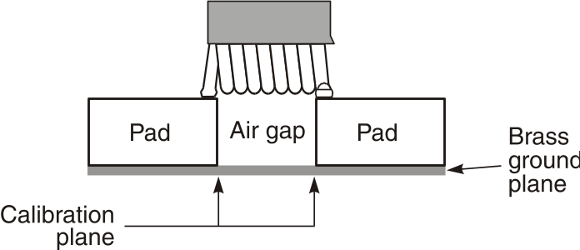
The measurements were made over a brass ground plane with each component centered over an air gap, as illustrated in Figure 1. The gap width for each size component is given in Table 1. The test pads were 30 mil (50 Ohm) wide traces of tinned gold over 25 mil thick alumina, and were not included in the gap. The TRL* calibration plane is also illustrated in Figure 1.

Figure 1 Test Setup

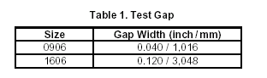

The S-parameters were generated by matching our simulation model as closely as possible to an average of the original measurements. The model was then used to create the final S-parameters. This method results in a model that represents as closely as possible the typical frequency-dependent behavior of the component within the specified frequency limits of the model. Because our simulation models were used to generate our 2-port S-parameters, they give identical results with the same number of simulation frequency points. The simulation models are available on our web site at http://www.coilcraft.com/models.cfm.

The valid frequency range for each part is specified in Table 1 below.

Table 1

Valid Frequency Range of S-parameters

Part Number | Range (MHz) |  | Part Number | Range (MHz)
0906-2 | 100 - 18000 |  | 1606-6 | 100 - 11000
0906-3 | 100 - 16000 |  | 1606-7 | 100 - 9500
0906-4 | 100 - 11000 |  | 1606-8 | 100 - 9000
0906-5 | 100 - 8000 |  | 1606-9 | 100 - 7500
 |  |  | 1606-10 | 100 - 6500

S-parameter file description.

All of the S-parameter data files are in the TouchStone format. The following is a typical data segment of a two-port file:

# MHZ S MA R 50
!Freq MagS11 AngS11 MagS21 AngS21 MagS12 AngS12 MagS22 AngS22
100 0.001 59.879 1.000 -0.036 1.000 -0.036 0.001 59.879
110 0.014 83.698 0.999 -0.798 0.999 -0.798 0.014 83.698
120 0.027 84.582 0.998 -1.558 0.998 -1.558 0.027 84.582
....

The first line (header) describes the frequency units, parameter, measurement format and characteristic impedance of the measurement (50 Ohms).
The first column is the frequency in MHz. The next columns are the S-parameters as described in the column headings.

Disclaimer

Coilcraft makes every attempt to provide accurate measurement data and software, representative of our components, in a usable format. Coilcraft, however, disclaims all warrants relating to the use of its data and software, whether expressed or implied, including without limitation any implied warranties of merchantability or fitness for a particular purpose. Coilcraft cannot and will not be liable for any special, incidental, consequential, indirect or similar damages occurring with the use of the data and/or software.

